Picturebook Workshop on Sat 6th July 2013

Exploring how to choose and use picturebooks to promote critical literacy, oral language and thinking skills in the primary school

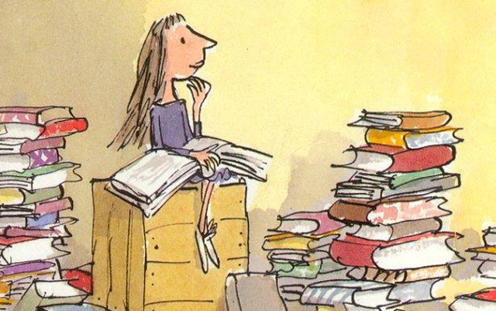

Would you like to spend a leisurely summer Saturday exploring a rich array of picturebooks and engaging in discussion with enthusiastic and energetic teachers who share a passion for using such books in the classroom?
Mary Roche will host and facilitate a one-day workshop in St Patrick’s College Thurles on developing an approach to using picturebooks in the primary school. The workshop will take place in St Pats THURLES on Sat 6th July 2013 from 9.30 am to 3.30pm.
Numbers are limited to 20 so prospective participants are advised to book early to guarantee a place.
If you want to learn more about choosing and using picturebooks for promoting critical literacy, oral language and thinking skills then contact Mary directly at mroche@stpats.ie or at 087-2222535 before July 3rd. There will be several teachers present who already use this teaching approach and they will be happy to share their knowledge and experience.
The workshop will be interactive and participants will be given opportunities to examine a range of books and discuss how they might be used with different age-groups.
The workshop is free but participants are advised to bring along a packed lunch.

